**The University of New Mexico**

**School of Engineering**

**Electrical and Computer Engineering Department**

**ECE 535 Satellite Communications**

**Student Name: Alex Hostick**

Student SN: 2O1

Module # 5-2: "Properties and Heights of Different Atmospheric Layers Above the Earth"

Fall 2023

**Prof. Tarief Elshafiey**

**Properties and Heights of Different Atmospheric Layers Above the Earth**

The atmosphere has significant effects on radio wave propagation. When radio waves of varying frequencies are transmitted to and from satellites, charged particles of the ionosphere degrade the signals through absorption and refraction. The tropospheric, the lowest densest part of the earth's atmosphere, can attenuate and obfuscate radio signals due to moisture and humidity. Layers of the atmosphere between the ionosphere and the troposphere contain oxygen, water vapor, clouds, and rain that add to attenuation and noise. This paper explores the effects of the atmosphere on radio wave propagation and how they may help or fraternize satellite communications.

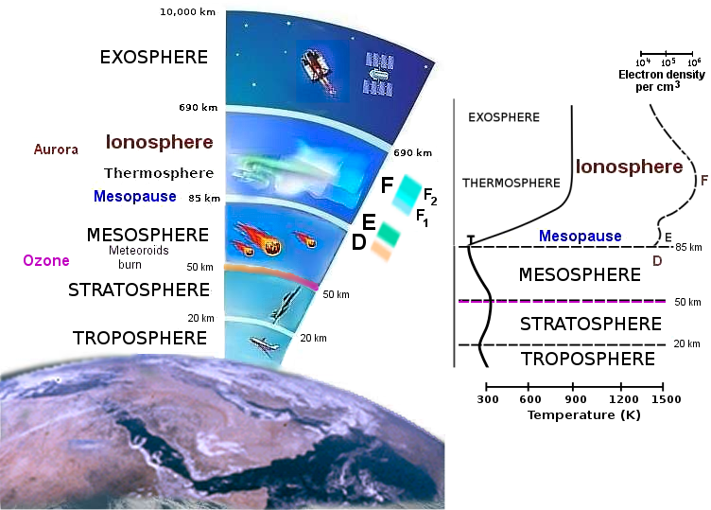

Figure 1 Atmosphere Layers

As illustrated in Figure 1, the atmosphere has multiple layers. Frequency bands typically associated with satellite communications, such as L, S, X, and K-band, are affected by atmospheric noise temperature and attenuation based on their wavelength and polarity. Figure 2 states the attenuation dB/km per frequency. As shown, lower frequencies typically experience less attenuation due to the absorbing characteristics of water, oxygen, and other gases.

Figure 2 Frequency Attenuation in the Atmosphere

**Ionospheric and Tropospheric Degradation**

A significant example of atmospheric effects is the Global Navigation Satellite System's (GNSS) navigation signals in the ionosphere. The delay of the signals depends on the electron density in the free electrons in the ionosphere. During the day, the sun's radiation causes the ionization of neutral atoms. Nighttime allows for the recombination of atoms to a neutral state. These perturbations in the ionosphere affect the navigation of 1-2GHz L-Band signals. According to Novatel, the most significant effect is scintillation, which can reduce link strength and cause considerable position accuracy (Novatel). Navigation is based on the satellite's pseudorange, and any delay will create poor accuracy over a region. Due to the refraction of the radio signal, the beam is bent and arrives at its destination with a delay (Katta, p. 98), as shown in Figure 3.

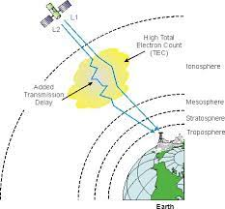

Figure 3 Signal Bent within Ionosphere

The troposphere's effect on GNSS signals causes delays in signal reception regardless of the frequency. L1, L2, and L5 frequencies are equally refracted, which means the range between a receiver and a satellite will be shown to be a bit longer than it is ("The Tropospheric Effect").

With high-frequency signals, rain can also reduce the reliability of communication links. ITU-R Model and Simple Attenuation Model (SAM) can approximate the degradation of rain attenuation. As the raindrop size approaches half the wavelength of the signal in diameter, the signal will be attenuated (4). This concludes that higher frequencies have a more significant amount of attenuation compared to lower frequencies. Depolarization can also occur during rain or ice in the atmosphere. While passing through the anisotropic medium, the wave exhibits attenuation and phase shift. Thus, its polarization state is altered, so power is transferred from the desired polarization state to the undesired orthogonal polarization state, resulting in interference (B.G, Ayantunji, p. 113).

**Circular Polarized Antennas**

When discussing satellite communication, linear or circular antennas should be weighed against one another. While vertical antennas excel in land-mobile applications, and horizontal antennas have been used in TV reception, circular polarized antennas excel in satellite communications. When a radio wave reaches the ionosphere, the electronics in the layer start an elliptical movement (Zubair, p. 87). For the Northern Hemisphere, the ordinary wave has the more significant delay and left-hand circular polarization (LHCP), and the extraordinary wave presents lesser uncertainty and right-hand circular polarization (RHCP) (Witvliet, 2015).

References

B.G, Ayantunji, et al. "Tropospheric Influences on Satellite Communications in Tropical Environment: A Case Study of Nigeria." *International Journal of Engineering and Innovative Technology (IJEIT)*, vol. 2, no. 12, June 2013, p. 113.

Davies, Kenneth. *Ionospheric radio*. No. 31. IET, 1990.

Katta, Mahesh Babu, et al. "A Systematic Study of 'Estimation of Ionospheric Delay Errors in GPS.'" *International Journal of Scientific and Research Publications*, vol. 7, no. 1, Jan. 2017, p. 98.

Witvliet B.A. "Near Vertical Incidence Skywave: Interaction of Antenna and Propagation Mechanism," *Ph.D. Thesis* *University of Twente; Enschede,* 2015

Zubair, Muhammad & Janjua, Zaffar & Khan, Shahid & Nasir, Jamal “Atmospheric influences on satellite communications.” *Przeglad Elektrotechniczny*, 2011, p. 87.

"The Tropospheric Effect, Dtrop." *The Tropospheric Effect, Dtrop | GEOG 862: GPS and GNSS for Geospatial Professionals*, www.e-education.psu.edu/geog862/node/1719#:~:text=The%20troposphere%20is%20refractive%2C%20its,between%20itself%20and%20the%20satellite. Accessed 11 Sept. 2023.

"What Is Ionospheric Activity and How Do I Mitigate against the Impact on GNSS?" *NovAtel*, novatel.com/tech-talk/ionospheric-activity#:~:text=The%20magnitude%20of%20the%20ionospheric,TEC)%20in%20the%20signal%20path. Accessed 11 Sept. 2023.